**Beam Detailing**

Following architectural drawings, beam section and layout in generated in ETABS. After the

performance of the design, the reinforcement requirement for the floor beams is created.

Using this information, the beams are designed accordingly. Structural drawing of the beams

are provided in the Appendix-A of this reports.

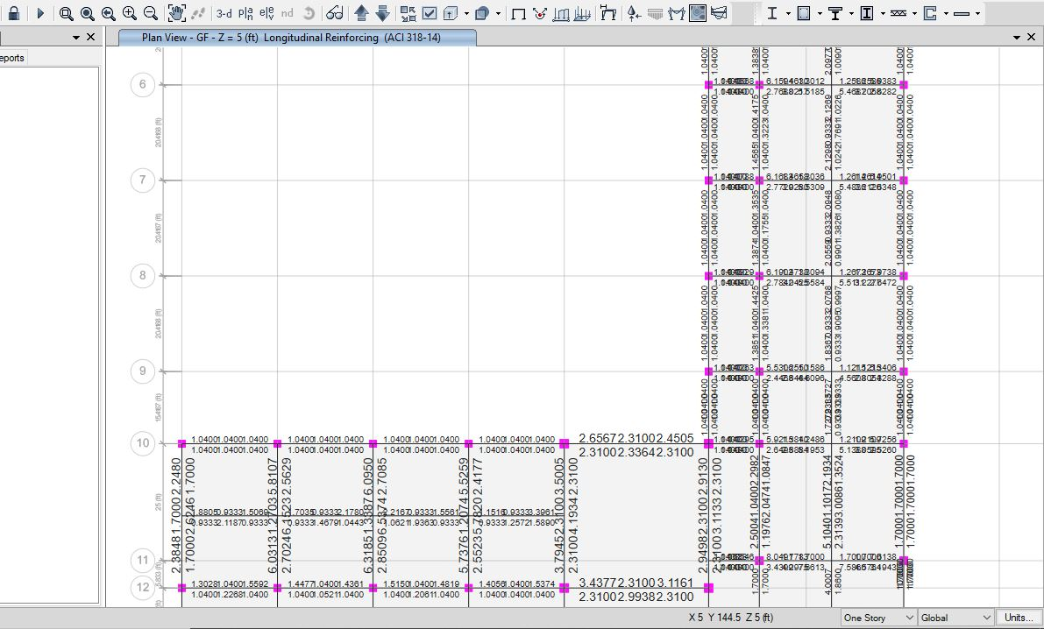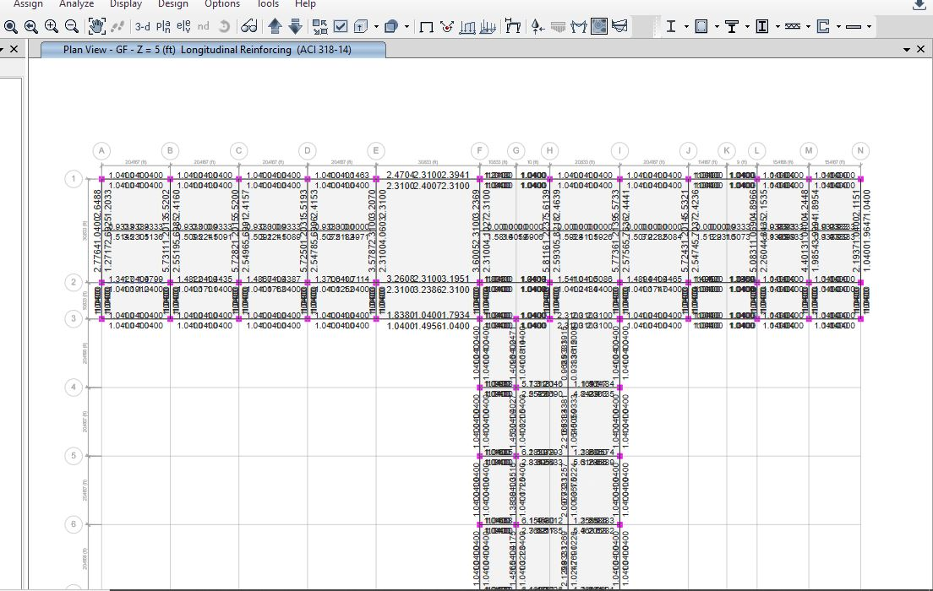

Figure: Longitudinal reinforcement of GF (z=5) (unit= in2 )

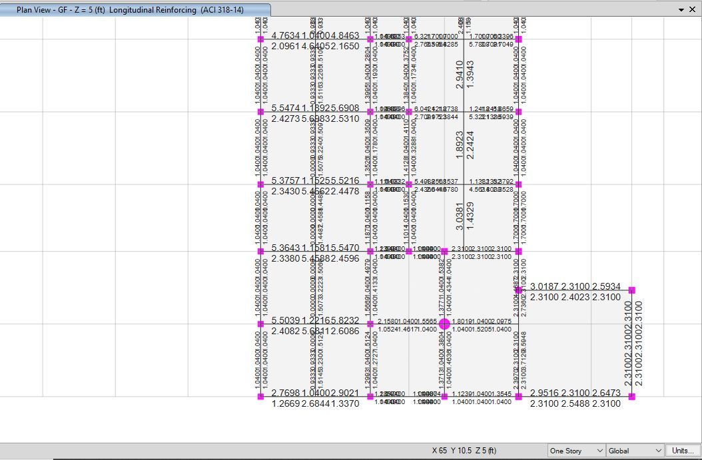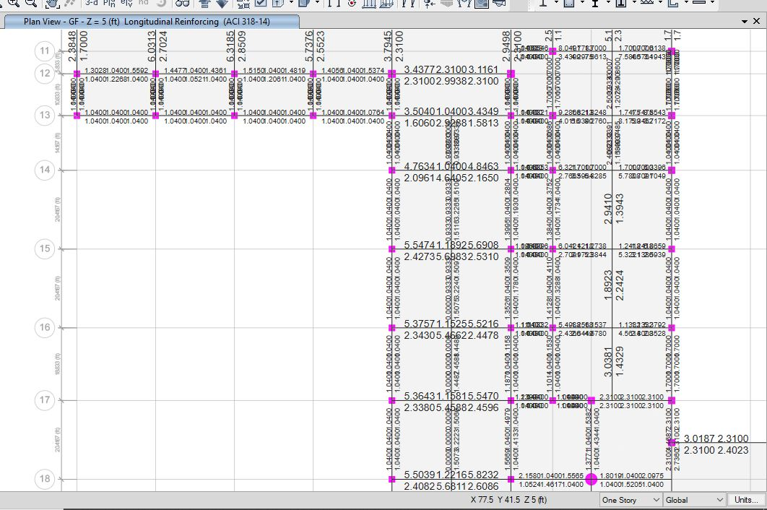

Figure: Longitudinal reinforcement of GF (z=5 ft) contd. (unit= in2 )

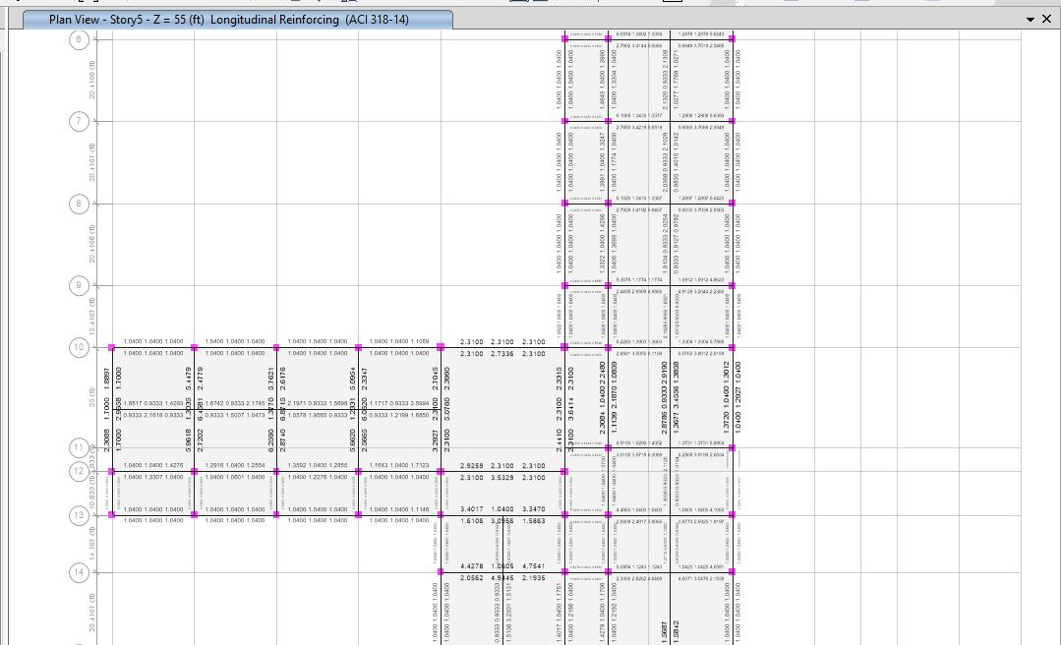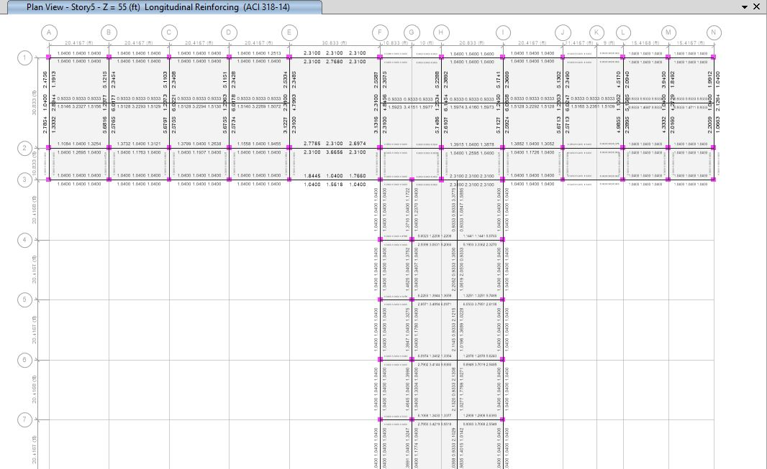

Figure: Longitudinal Reinforcement of Level-5 (z=55 ft) (Unit= in2)

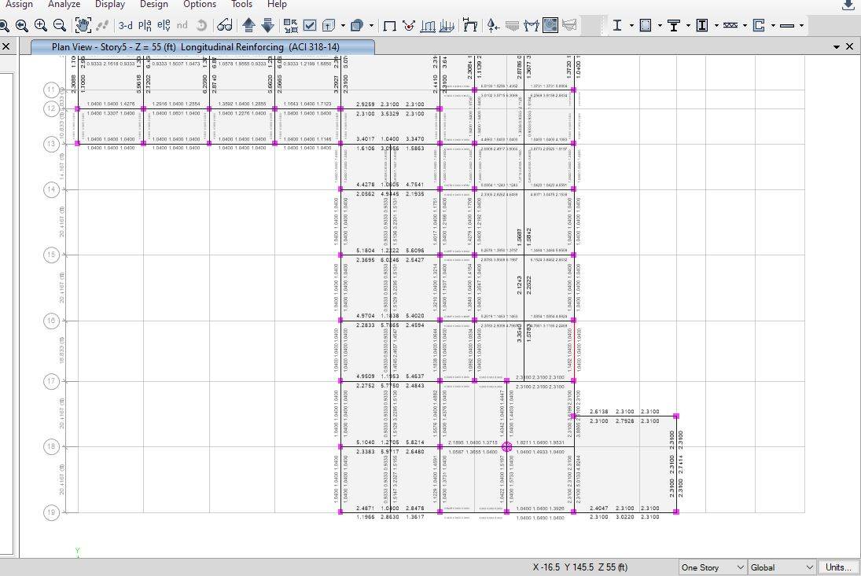

Figure: Longitudinal Reinforcement of Level-5 (z=55 ft) contd. (Unit= in2)

Here 5 types of beams are strategically deployed throughout the structure. MB-1 (16X22), MB-2 (18X24) and SB 16X20 are generally used in all floors and functions as T-beam. No. 4 stirrup is used as provided rebar sizes are equal to or above No. 9. The whole design and spacing adheres to the IMRF formula.

The Required and the provided reinforcement is compared and found satisfactory.

Table 1: Required Reinforcement and Provided Reinforcement comparison:

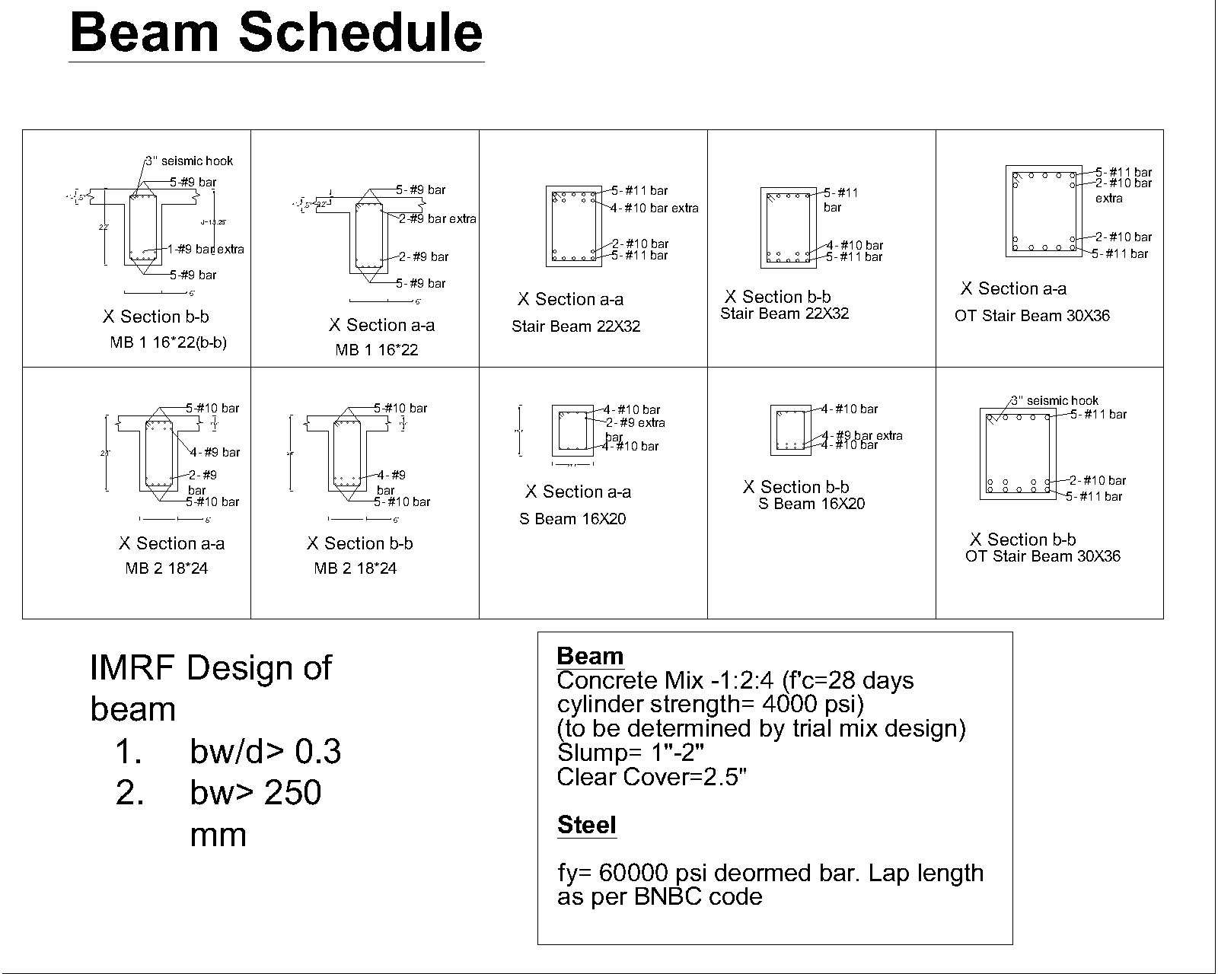

Figure: Beam schedule

**Table 1:**

|  |  |  |  |  |  |  |  |  |
| --- | --- | --- | --- | --- | --- | --- | --- | --- |
| **1ST FLOOR** | | **BEAM DATA** | | | | | | |
| **Label** | **Beam Name** | **Reinforcement (sqin)** | | | | | | |
| **Position** | **Top Req.(in2)** | **Top Provided**  **(in2)** | **OK/**  **Not Ok** | **Bot. rq**  **(in2)** | **Bot. Provided**  **(in2)** | **Ok/**  **Not Ok** |
| B4 | MB 1 16*22 | left | 1.05 | 7 | Ok | 1.04 | 7 | OK |
| B4 | MB 1 16*22 | Mid | 1.04 | 5 | Ok | 1.04 | 8 | OK |
| B4 | MB 1 16*22 | Right | 1.293 | 7 | Ok | 1.04 | 7 | OK |
| B203 | SB 16*20 | Left | 0.93 | 6 | Ok | 1.51 | 6 | OK |
| B203 | SB 16*20 | Mid | 0.93 | 4 | Ok | 3.23 | 8 | OK |
| B203 | SB 16*20 | Right | 0.93 | 6 | Ok | 1.515 | 6 | OK |
| B210 | SB 16*20 | Left | 0.933 | 6 | Ok | 1.6 | 6 | OK |
| B210 | SB 16*20 | Mid | 0.933 | 4 | Ok | 3.42 | 8 | OK |
| B210 | SB 16*20 | Right | 0.933 | 6 | Ok | 1.59 | 6 | OK |
| B17 | MB 1 16*22 | Left | 1.53 | 7 | Ok | 1.04 | 7 | OK |
| B17 | MB 1 16*22 | Mid | 1.04 | 5 | Ok | 1.104 | 8 | OK |
| B17 | MB 1 16*22 | Right | 1.84 | 7 | Ok | 1.04 | 7 | OK |
| B22 | MB 1 16*22 | Left | 1.657 | 7 | Ok | 1.04 | 7 | OK |
| B22 | MB 1 16*22 | Mid | 1.04 | 5 | Ok | 1.18 | 8 | OK |
| B22 | MB 1 16*22 MB 1 16*22 | Right | 1.6 | 7 | Ok | 1.04 | 7 | OK |
| B31 | MB 1 16*22 | left | 1.98 | 7 | Ok | 1.04 | 7 | OK |
| B31 | MB 1 16*22 | Mid | 1.04 | 5 | Ok | 1.52 | 8 | OK |
| B31 | MB 1 16*22 | Right | 1.91 | 7 | Ok | 1.04 | 7 | OK |
| B270 | SB 16*20 | Left | 2.1343 | 6 | Ok | 1.0287 | 6 | OK |
| B270 | SB 16*20 | Mid | 0.933 | 4 | Ok | 1.78 | 8 | OK |
| B270 | SB 16*20 | Right | 2.1315 | 6 | Ok | 1.03 | 6 | OK |
| B74 | MB 1 16*22 | left | 1.04 | 7 | Ok | 1.04 | 7 | OK |
| B74 | MB 1 16*22 | Mid | 1.04 | 5 | Ok | 1.04 | 8 | OK |
| B74 | MB 1 16*22 | Right | 1.04 | 7 | Ok | 1.04 | 7 | OK |
| B223 | MB 1 16*22 | left | 5.77 | 7 | Ok | 2.624 | 7 | OK |
| B223 | MB 1 16*22 | Mid | 1.41 | 5 | Ok | 2.86 | 8 | OK |
| B223 | MB 1 16*22 | Right | 1.26 | 7 | Ok | 4.95 | 7 | OK |
| B233 | MB 1 16*22 | left | 6.24 | 7 | Ok | 2.86 | 7 | OK |
| B233 | MB 1 16*22 | Mid | 1.58 | 5 | Ok | 3.15 | 8 | OK |
| B233 | MB 1 16*22 | Right | 1.37 | 7 | Ok | 5.65 | 7 | OK |
| B179 | SB 16*20 | left | 2.22 | 6 | Ok | 4.067 | 6 | OK |
| B179 | SB 16*20 | Mid | 0.933 | 4 | Ok | 1.946 | 8 | OK |
| B179 | SB 16*20 | Right | 1.58 | 6 | Ok | 0.93 | 6 | OK |
| B142 | MB 1 16*22 | left | 1.576 | 7 | Ok | 1.04 | 7 | OK |
| B142 | MB 1 16*22 | Mid | 1.04 | 5 | Ok | 1.04 | 8 | OK |
| B142 | MB 1 16*22 | Right | 1.78 | 7 | Ok | 1.04 | 7 | OK |
| B87 | Stair Beam 22*32 | left | 3.93 | 11.8 | Ok | 2.31 | 10.34 | OK |
| B87 | MB 1 16*22 | Mid | 2.31 | 7.8 | Ok | 4.54 | 12.88 | OK |
| B87 | MB 1 16*22 | Right | 3.74 | 11.8 | Ok | 2.31 | 10.34 | OK |
| B18 | Stair Beam 22*32 | left | 3.66 | 11.8 | Ok | 2.31 | 10.34 | OK |
| B18 | Stair Beam 22*32 | Mid | 2.31 | 7.8 | Ok | 3.38 | 12.88 | OK |
| B18 | Stair Beam 22*32 | Right | 3.54 | 11.8 | Ok | 2.31 | 10.34 | OK |
| B51 | Stair Beam 22*32 | left | 3.78 | 11.8 | Ok | 2.31 | 10.34 | OK |
| B51 | Stair Beam 22*32 | Mid | 2.31 | 7.8 | Ok | 4.32 | 12.88 | OK |
| B51 | Stair Beam 22*32 | Right | 3.61 | 11.8 | Ok | 2.31 | 10.34 | OK |
| B121 | MB 1 16*22 | left | 1.49 | 7 | Ok | 1.04 | 7 | OK |
| B121 | MB 1 16*22 | Mid | 1.04 | 5 | Ok | 1.24 | 8 | OK |
| B121 | MB 1 16*22 | Right | 1.44 | 7 | Ok | 1.04 | 7 | OK |
| B148 | MB 1 16*22 | left | 3.64 | 7 | Ok | 1.72 | 7 | OK |
| B148 | MB 1 16*22 | Mid | 1.04 | 5 | Ok | 2.98 | 8 | OK |
| B148 | MB 1 16*22 | Right | 3.61 | 7 | Ok | 1.7 | 7 | OK |
| B250 | MB 1 16*22 | left | 6.56 | 7 | Ok | 3.03 | 7 | OK |
| B250 | MB 1 16*22 | Mid | 1.82 | 5 | Ok | 3.25 | 8 | OK |
| B250 | MB 1 16*22 | Right | 1.44 | 7 | Ok | 5.94 | 7 | OK |
| B175 | MB 1 16*22 | left | 4.9 | 7 | Ok | 2.25 | 7 | OK |
| B175 | MB 1 16*22 | Mid | 1.1 | 5 | Ok | 4.7 | 8 | OK |
| B175 | MB 1 16*22 | Right | 4.94 | 7 | Ok | 2.27 | 7 | OK |
| B174 | MB 1 16*22 | left | 5.7 | 7 | Ok | 2.58 | 7 | OK |
| B174 | MB 1 16*22 | Mid | 1.26 | 5 | Ok | 5.8 | 8 | OK |
| B174 | MB 1 16*22 | Right | 5.76 | 7 | Ok | 2.62 | 7 | OK |
| B173 | MB 1 16*22 | left | 5.53 | 7 | Ok | 2.51 | 7 | OK |
| B173 | MB 1 16*22 | Mid | 1.21 | 5 | Ok | 5.55 | 8 | OK |
| B173 | MB 1 16*22 | Right | 5.57 | 7 | Ok | 2.53 | 7 | OK |
| B172 | MB 1 16*22 | left | 5.55 | 7 | Ok | 2.52 | 7 | OK |
| B172 | MB 1 16*22 | Mid | 1.22 | 5 | Ok | 5.55 | 8 | OK |
| B172 | MB 1 16*22 | Right | 5.62 | 7 | Ok | 2.54 | 7 | OK |
| B171 | MB 1 16*22 | left | 5.74 | 7 | Ok | 2.61 | 7 | OK |
| B171 | MB 1 16*22 | Mid | 1.3 | 5 | Ok | 5.78 | 8 | OK |
| B171 | MB 1 16*22 | Right | 5.91 | 7 | Ok | 2.7 | 7 | OK |
| B186 | Stair Beam 22*32 | left | 3.51 | 11.8 | Ok | 2.31 | 10.34 | OK |
| B186 | Stair Beam 22*32 | Mid | 2.31 | 7.8 | Ok | 2.54 | 12.88 | OK |
| B186 | Stair Beam 22*32 | Right | 3.19 | 11.8 | Ok | 2.31 | 10.34 | OK |
| B112 | MB 1 16*22 | left | 1.04 | 7 | Ok | 1.04 | 7 | OK |
| B112 | MB 1 16*22 | Mid | 1.04 | 5 | Ok | 1.04 | 8 | OK |
| B112 | MB 1 16*22 | Right | 1.04 | 7 | Ok | 1.04 | 7 | OK |
| B250 | MB 2 18*24 | Left | 7.15 | 10.35 | Ok | 3.35 | 8.35 | OK |
| B250 | MB 2 18*24 | Mid | 1.76 | 6.35 | Ok | 3.89 | 10.35 | OK |
| B250 | MB 2 18*24 | Right | 1.59 | 10.35 | Ok | 6.8 | 8.35 | OK |
| B251 | MB 2 18*24 | left | 1.49 | 10.35 | Ok | 6.75 | 8.35 | OK |
| B251 | MB 2 18*24 | Mid | 1.49 | 6.35 | Ok | 4.21 | 10.35 | OK |
| B251 | MB 2 18*24 | Right | 6.68 | 10.35 | Ok | 3.1 | 8.35 | OK |
| B87 | OT stair beam 30*36 | left | 4.14 | 10.34 | Ok | 3.35 | 10.34 | OK |
| B87 | OT stair beam 30*36 | Mid | 3.35 | 7.8 | Ok | 7.86 | 12.88 | OK |
| B87 | OT stair beam 30*36 | Right | 3.45 | 10.34 | Ok | 3.87 | 10.34 | OK |

**Slabs**

**Design of Slabs**

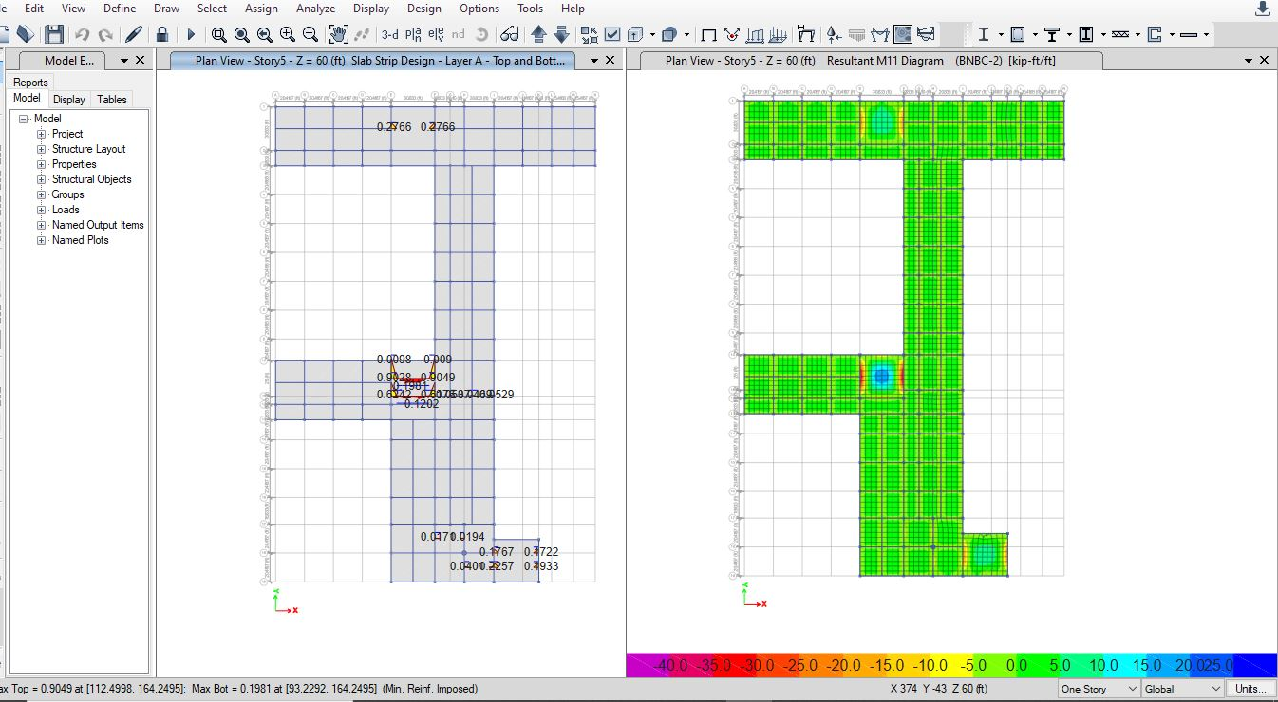The design of roof slab was performed using ETABS slab analysis (Both FEM and Strip method). After the analysis was performed, values of reinforcement requirement was determined.

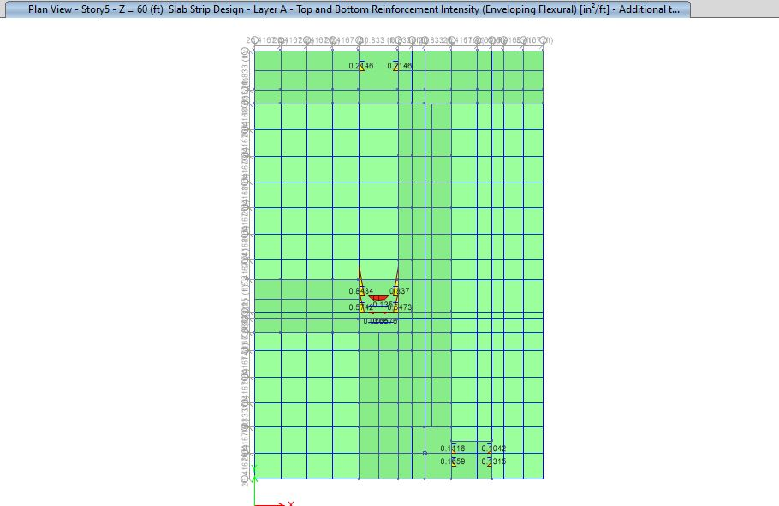

**Figure:** Design of slab using ETABS

After design, following Reinforcements are chosen

|  |  |  |
| --- | --- | --- |
| Axis | Top | Bottom |
| X- axis | #5 @9’’ c/c | #5 @14’’ c/c |
| Y- axis | #5 @8’’ c/c | #5 @14’’ c/c |

No cranked bars or shear reinforcements are used. As the building shape is large and irregular, a certain portion of slab reinforcement was shown in detail drawing appendix.

Serviceability Check of Slabs

In assessing safety of slab the following parameters need to study:

(1) Serviceability

(2) Strength

To ensure the serviceability thickness of the slab shall conform to the minimum specifications of BNBC 2006 and ACI 318-08. According to ACI code the minimum slab thickness shall be as follows to be adequate in serviceability.

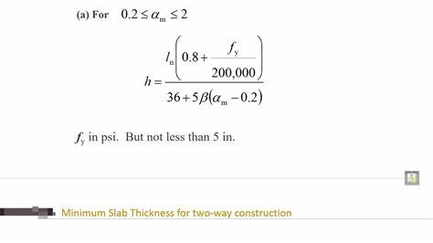Here most slab panels have unique dimension, but all of them are two way slabs. Minimum thickness for two way slab formula is as follows:

Highest required thickness was 5.9’’ and provided thickness was 6’’.

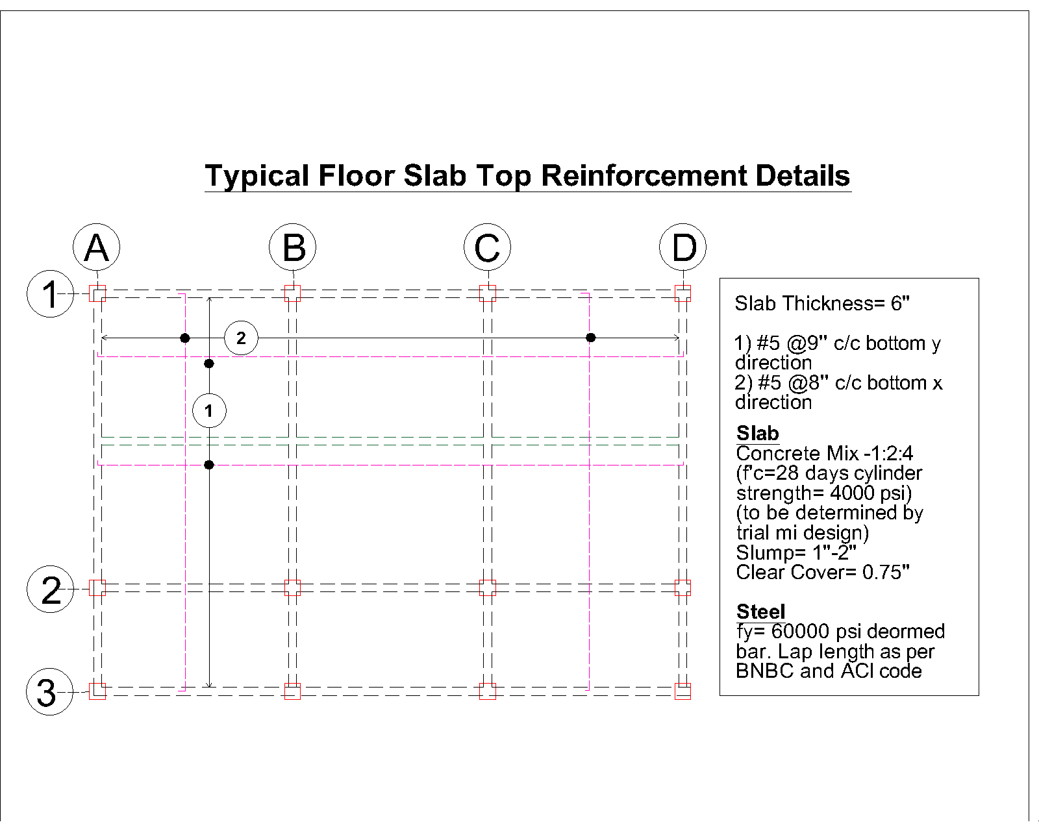

Figure: Reinforcement detailing of slab (Top)

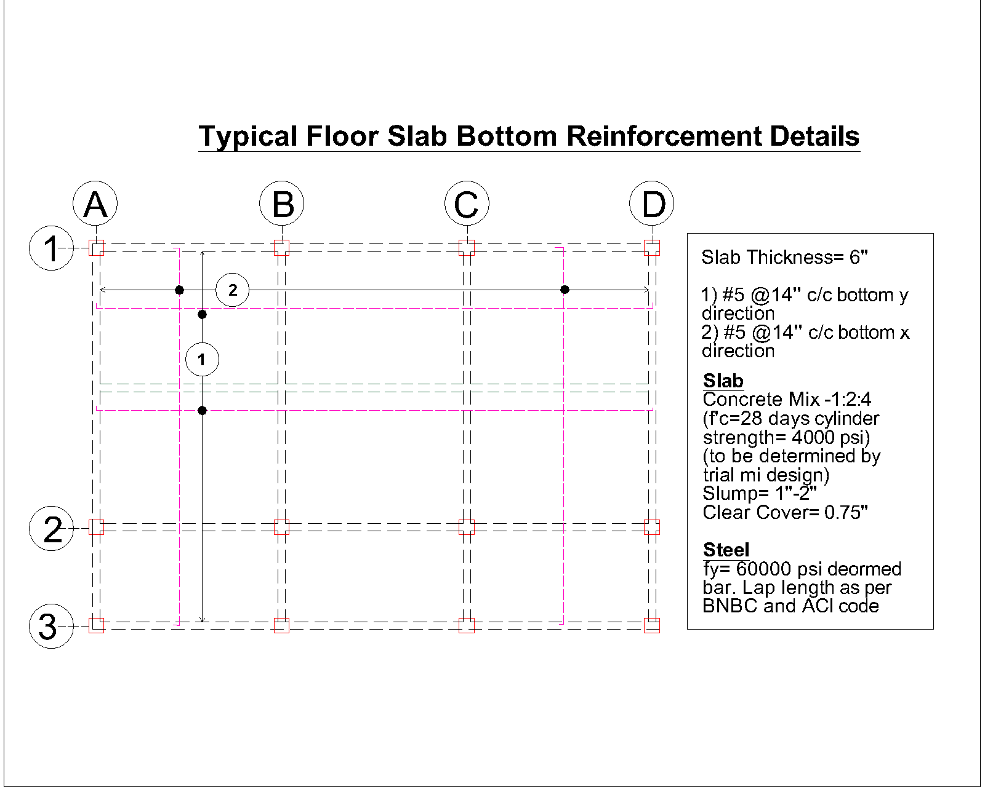

Figure: Reinforcement of slab (Bottom)

**Stairs**

**Stair Dimensions:**

|  |  |
| --- | --- |
| Riser Height: | 6 inches |
| Going Length: | 10 inches |
| Thickness of Stair Slab: | 6 inches |

**Load Information:**

|  |  |
| --- | --- |
| Live Load | 100 psf |
| Covering Material Self-Weight | 25 psf |

**Material Properties:**

|  |  |
| --- | --- |
| Concrete Compressive Strength (f'c) | 3 ksi |
| Steel Yield Strength (Fy) | 40 ksi |

**Reinforcement**:

|  |  |
| --- | --- |
| Temperature and Shrinkage #3 | Smax=18-inch c/c  Sprovided=10-inch c/c |
| Main Bar #4 | Smax=18-inch c/c  Sprovided=9-inch c/c |

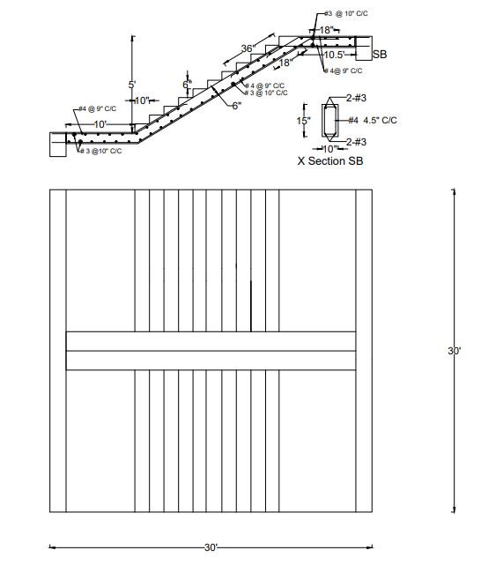

**Figure:** Stairs Reinforcement detail

**Safety of the Building:**

1.Storey Drift

Story drift is the displacement of one level relative to the level above or below due to the design

lateral forces except otherwise permitted in BNBC sec 1.3.4.2 (a) calculated Storey drift shall

include both translation and torsional deflection and conform to the following requirements.

**Wind Drift**: Storey drift, ∆, for loads other than earthquake loads, shall be limited as follows:

1. ∆ ≤ 0.005ℎ for T < 0.7 second

2. ∆ ≤ 0.004ℎ for T≥ 0.7 second

3. ∆ ≤ 0.0025ℎ for unreinforced masonry structures. Where, ℎ = height of floor & T= Time Periods (Source: BNBC Part VI; Section 1.5.6.1)

For the main building, T= 0.779 sec (So, T < 0.7 second) Height of floor, H= 15 ft

Maximum Drift Limit= 0.004h= .004*75*12= 3.6’’

**Combination:** WL along X direction

Drift= 1.9’’<3.6’’ (OK)

Along Y direction,

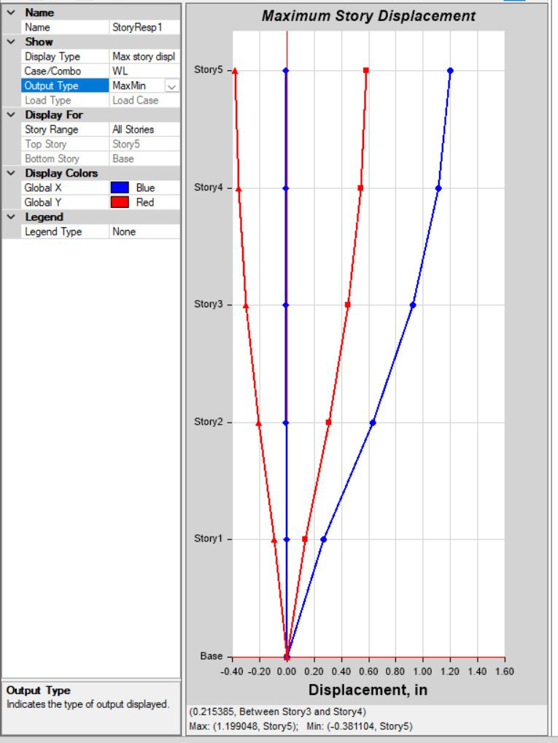Drift= 0.58<3.6’’

**Earthquake Drift:** No earthquake drift was detected.